**LABORATORY 3: ENTHALPHY OF MIXING**

**CHEM 3150 PHYSICAL CHEMISTRY**

**WPU-CHEMISTRY DEPARTMENT**

**BACKGROUND:**

The inter-dissolution of two substance is a phenomenon controlled by a reduction of free energy (either Gibbs or Helmholtz), as such it has an enthalpy and entropy components.

There are two factors that can drive processes to occur. The first is the heat exchanged as a result of the process. This is referred to as the “change in enthalpy” and sometimes as “the heat of reaction”. If heat is released in the process (H< 0), it favors the feasibility of the reaction to occur. The second is the change in the state of order in the system. This is referred to as the “change in entropy”. A process that results in a more disordered state (higher number of configurational states available) favors spontaneity (S≥0) as per the Second Law of Thermodynamics. These two factors will contribute to define the free energy of the system (either Gibbs or Helmholtz) and determining whether a process is indeed spontaneous. The change in Gibbs free energy (G) which is a function of the change in enthalpy (H) and the change in entropy (S). If G is negative, the reaction occurs spontaneously otherwise it does not occur spontaneously. Thus, any spontaneous endothermic process has to be driven by a positive change in entropy.

G = H - TS

Notice that even though the reaction may occurs spontaneously, the change in G does not tell anything about the rate of the reaction or the kinetics of the reaction. The later are controlled by reaction kinetic factors.

Intermolecular interaction between the substances play a role in the miscibility of two substances. The miscibility of polar solvents, such as water and ethanol are based, in part, on hydrogen bonding. Pure water exists as spheres of 10-30 water molecules held together via hydrogen bonds. Pure ethanol is similar, but generally the clusters of ethanol are smaller. As we will soon verify, these two solvents are completely miscible in all proportions.

What happens to the intermolecular bonding structure when these two solvents are mixed? Some water-water hydrogen bonds and ethanol-ethanol hydrogen bonds are broken and some water-ethanol hydrogen bonds are formed. The process of breaking bonds is endothermic (heat is absorbed by the molecules and the energy is used to break the bonds). The process of making bonds is exothermic (heat is released). By measuring the temperature change of the solutions upon mixing, one can assess whether a net number of hydrogen bonds were formed or broken upon mixing. Because molecules that are on the inside of the sphere are generally involved in more hydrogen bonding than those on the surface of the sphere, an exothermic mixing suggests that bigger clusters were formed and an endothermic mixing suggests that mixing has resulted in smaller solvent clusters.

Consequently, more configurational states are available (water-ethanol states) for each molecule that the original water-water and ethanol-ethanol ones. Therefore, entropy increases after the dissolution of the two substances.

Similarly rationale may be used from non-polar substances but considering dispersion forces instead. A broader scope of the phenomena occurs when all inter-molecular forces discussed in College Chemistry are considered.

*Question1: In College Chemistry we learn a definition of solvation; however, the molecular mechanism of dissolution to achieve solvation in the case of a solid-liquid or liquid-liquid was never touched. Search/investigate for the molecular mechanism that allows solvation to happen?*

However, we can realize that even if **no interactions occur** between the molecules, the mixing of two substance may occur due to the entropic contribution lowering the Gibbs free energy.

For an ideal solution of liquid 1 and liquid 2 the following applies:

*Hmix = 0*

Therefore the only component of the free energy is the one related to entropy:

*Gmix = RT (x1 ln x1 + x2 ln x2) Eq.1*

Where *xi* are the molar fractions of the corresponding liquid

Additionally from College Chemistry you are familiar with the relationship between heat flow and specific heat capacity (*s.h.*)

Q = *m × s.h. × T Eq. 2*

The net heat flow/change from the dissolution process can be calculated using this relationship when the amount of one of the substances dissolved (solute) is small compared to the amount of the other one (solvent) or what is called a diluted solution.

*Question2: In this laboratory we will be considering solutions which are not considered “diluted”, how you deal with the heat flow calculations in such situations?*

Preparing for this laboratory, read the following material:

1. Chapter 6, Sections 6.5 to 6.6 and Chapter 9, Sections 9.1 to 9.3 from the Physical-Chemistry text book
2. *“Solution Calorimetry Experiments for Physical Chemistry”*, D. A. Raizen, B. M. Fung, and S. D. Christian, *Jou. Chem. Education*, page 933 reference provided.
3. College Chemistry background in Thermochemistry needed.

**SAFETY:**

1. **USE GOGGLES AT ALL THE TIME WHILE WORKING IN THE LAB**
2. **IN THIS EXPERIMENT WE WILL MIX HOT LIQUIDS AS WELL AS VOLATILE LIQUIDS USE GLOVES AND HANDLE VOLATILE LIQUIDS IN THE HOOD.**

**MATERIALS AND EQUIPMENT:**

1. Calorimeter:

* Dewar flask Calorimeter. Synthware Glass, Inc.
* Calorimeter cap made from insulation material

*Question 3: Search/investigate for the heat capacity, thermal conductivity, and density of glass, stainless steel, Teflon and magnetic alloys. How this information may allow you to design and build a better calorimeter?*

1. Two Thermometers
2. Small Teflon stirring rod
3. Test samples:
   1. Distilled water
   2. Cyclohexane
   3. Ethanol
   4. Acetone
4. Two 50 mL graduate cylinders
5. One 10 mL graduated cylinder

**EXPERIMENTAL SETUP:**

1. **Experimental schematic**

We will use glass vacuum jacket isolated calorimeter and a thermometer as shown in Figure 1. An insulating top for the cup will have the following holes/ports:

1. A hole in it where you can stick a thermometer
2. A hole closed with a stopper for addition of liquid using a funnel.

The calorimeter will also include a stirrer bar inside the calorimeter to facilitate mixing of the liquids. Do not stir aggressively the liquids or you will create cavitation.

*Question4: Why you should not stir aggressively the liquids and what will be the impact of cavitation in the results?*

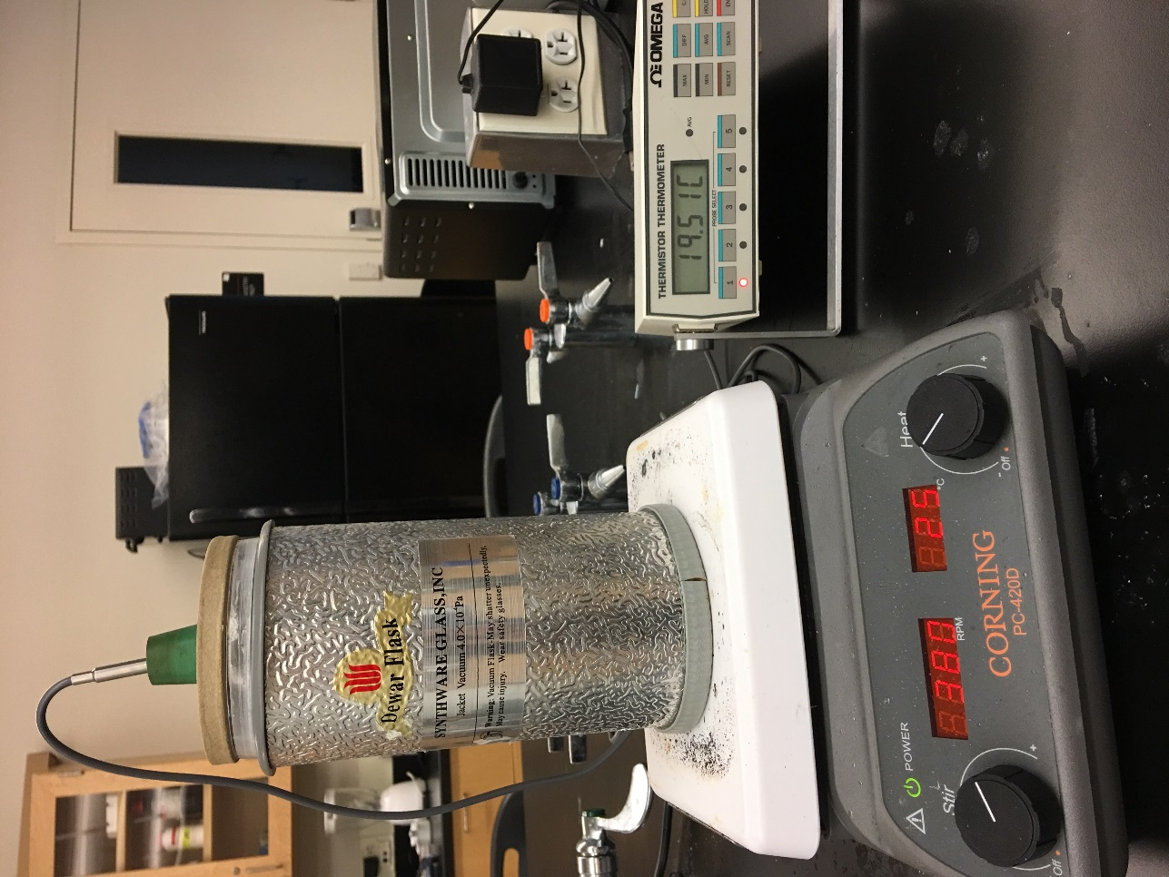

**Figure 1.** Experimental setup

**EXPERIMENTAL PROCEDURE:**

1. **Characterization of the Calorimeter**

Determine the accuracy and errors of the graduated cylinders

After the system is set up and you have read and understood the procedure and goals of the experiment proceed with the experimental part below.

The heat capacity of a calorimeter depends of the masses (calorimeter and solutions been evaluated) and the temperatures of the system (calorimeter + solution, and outside temperature) consequently we need to establish the losses function of the calorimeter for several temperatures (at least four)

* 1. Measure accurately two 30 mL aliquots of water, determine their masses.
  2. Pour the first amount into the calorimeter, have the stirrer spinning moderately, and let the temperature stabilize for a reasonable time (5 to 10 minutes observing its temperature).
  3. Heat the second amount of water to about 40-50oC (Do not boil it or let evaporate it significantly), let the temperature stabilize for 2-3 minutes and record the last temperature.
  4. Pour the water into the calorimeter and cap it immediately. Record the maximum/minimum temperature reached by the solution.
  5. Empty the calorimeter and fill it with ambient temperature water for at least 1 minute to cool/warm the glass jacket to RT. ***Failing to do so will impact the stability of your temperature reading for the liquid on the calorimeter.***

Repeat the procedure 1.1 to 1.4 for a second temperature between 30-40oC (in step 1.3), and a third temperature between 5-15oC.

From the experimental data and the fitting function heat capacity vs. Tmax and considering their deviation from the final temperature values for the mixtures to be evaluated in Section 2, you should be able to calculate/estimate the heat capacity of the calorimeter as well as the heat losses through its walls on each case.

Plot heat capacity of the calorimeter as a function of Tmax.

*Question 5: Does the values determined in this part apply to any temperature?*

1. **Measurements of the Enthalpy of Mixing**

Reference:

1. *“Solution Calorimetry Experiments for Physical Chemistry”*, D. A. Raizen, B. M. Fung, and S. D. Christian, *Jou. Chem. Education* 65, 932-933 (1988)
2. *“Endothermicity or exothermicity of water/alcohol mixtures”*, D. Peeters, P. Huyskens, *Jou. Molecular Structure* **300**, 539-550 (1993)

In all the experiments to be considered the total volume of the mixtures will be 60 mL. This is very important since the heat capacity/losses of the calorimeter have been determined with same volume/mass.

After characterizing of your calorimeter proceed with the experimental part below.

Measure the enthalpy of mixing of ethanol and cyclohexane as follows.

**Table 1. Cyclohexane:Ethanol** mixing table. The table has the values for different groups (color coded)

|  |  |  |  |  |  |  |
| --- | --- | --- | --- | --- | --- | --- |
| Mixture | Cyclohexane (mL) | | | Ethanol (mL) | | |
| 1 | 55 | 50 | 57 | 5 | 10 | 3 |
| 2 | 40 | 45 | 35 | 20 | 15 | 25 |
| 3 | 30 | 25 | 20 | 30 | 35 | 40 |
| 4 | 20 | 15 | 10 | 40 | 45 | 50 |
| 5 | 10 | 5 | 3 | 50 | 55 | 57 |
| Use separate graduated cylinders one for each liquid (so to prevent any prior mixing) | | | | | | |

For each mixture in Table 1 proceed as follows:

1. Whichever solvent is largest in volume in the particular trial you are performing will be measured using a graduated cylinder and poured into the calorimeter.

Gently stir the mixture using a stir bar and the stir function of the hot plate (Do not use Heat)

Place the top on and record the initial temperature of the solvent. Start the moderated stirring and monitor the temperature until it stabilized. Remember if the solvents are volatile, you should proceed relatively fast accordingly.

1. Keep the second so/vent in the separate graduate cylinder and measure its temperature using another thermometer. Let the temperature stabilize and record the temperature
2. With the thermometer in place, have another person quickly (but carefully) pour the second solvent into the calorimeter. Other person should keep monitoring and recording the temperature in the calorimeter.

The temperature of the solvent will change fairly rapidly upon mixing and should level out momentary at a new temperature after few seconds (~ 20-30 s) Record the temperature then.

1. Empty the calorimeter into a secondary beaker and observe the mixed solution. Record your observations.
2. Fill the calorimeter with RT water for at least 1-2 minutes, then empty it and dry its interior. ***Failing to do so will impact the stability of your temperature reading for the liquid on the calorimeter.***
3. Repeat the procedure for the mixtures in Table 2 and 3 as assigned to each group.

**Table 2.** Water-Ethanol mixing table

|  |  |  |  |  |  |  |
| --- | --- | --- | --- | --- | --- | --- |
| Mixture | W (mL) | | | Ethanol (mL) | | |
| 1 | 55 | 53 | 57 | 5 | 7 | 3 |
| 2 | 50 | 52 | 48 | 10 | 8 | 12 |
| 3 | 45 | 48 | 43 | 15 | 12 | 17 |
| 4 | 40 | 35 | 38 | 20 | 25 | 22 |
| 5 | 35 | 33 | 36 | 25 | 27 | 24 |
| 6 | 30 | 30 | 30 | 30 | 30 | 30 |
| 7 | 25 | 20 | 15 | 35 | 40 | 45 |
| 8 | 20 | 10 | 5 | 40 | 50 | 55 |
| Use separate graduated cylinders one for each liquid (so to prevent any prior mixing) | | | | | | |

**Table 3.** Cyclohexane- Acetone mixing table

|  |  |  |  |  |  |  |
| --- | --- | --- | --- | --- | --- | --- |
| Mixture | Water (mL) | | | Acetone (mL) | | |
| 1 | 55 | 53 | 57 | 5 | 7 | 3 |
| 2 | 50 | 47 | 46 | 10 | 13 | 14 |
| 3 | 45 | 40 | 43 | 15 | 20 | 17 |
| 4 | 40 | 35 | 30 | 20 | 25 | 30 |
| 5 | 35 | 30 | 25 | 25 | 30 | 35 |
| 6 | 30 | 25 | 20 | 30 | 35 | 40 |
| 7 | 10 | 20 | 5 | 50 | 40 | 55 |
| Use separate graduated cylinders one for each liquid (so to prevent any prior mixing) | | | | | | |

**DATA ANALYSIS:**

1. Search for the specific heat of water, cyclohexane, acetone and ethanol at the temperatures and pressure of the substances in this experiment. If not available, use the ones for each liquid at the initial temperatures.
2. Search for the density of water, cyclohexane, acetone and ethanol at the initial temperatures to be able to calculate the masses of each solvent in each experiment.
3. Calculate the corresponding mole fractions for each experiment.

*Question 5: What do you expect for the s.h and density dependence on pressure and temperature?*

1. Calculate for each experiment the ideal solvent mixing free energy as per Eq. 1
2. Calculate the total heat from the mixing using Eq 2 and considering gain/losses of the calorimeter.
3. Calculate the net *Hmix* by subtracting calculation in 4 from total heat calculated in 5.
4. Plot *Hmix vs.* mole fraction of ethanol or acetone depending of each mixture.
5. Plot *T × Smix, ideal vs.* mole fraction of ethanol
6. Discuss your results:
   1. Does it deviates from ideal? And if it does, why?
   2. How it dos depends and deviates as a function of molar fraction of ethanol, cyclohexane, or acetone depending of each case?
   3. How the results in experiment Table 2 correlate to results from experiment Table 3?

**ADDITIONAL QUESTIONS:**

1. Explain/discuss in your own words, what an ideal solution is? Is there a truly ideal solution?
2. Why is *Hmix* =0 for an ideal solution?
3. Why is *Smix* >0 for an ideal solution?
4. Compared to the mixing of an ideal solution, is the mixing of ethanol and cyclohexane more or less thermodynamically favorable (as determined by your experimental *Gmix*)? How does your answer depend on the mole fraction?
5. Compared to the mixing of an ideal solution, is the mixing of ethanol and water more or less thermodynamically favorable (as determined by your experimental *Gmix*)? How does your answer depend on the mole fraction?
6. Compared to the mixing of an ideal solution, is the mixing of acetone and cyclohexane more or less thermodynamically favorable (as determined by your experimental *Gmix*)? How does your answer depend on the mole fraction?
7. Explain the meaning of *Gexcess* in the Reference article, Table 2.
8. What is the role of intermolecular forces in this experiment?

**Record Form for Each Experiment**

|  |  |  |  |  |
| --- | --- | --- | --- | --- |
| **Experiment:** | | | | |
| **Solvent 1: Solvent 2:** | | | | |
| Tini-1 (oC) | Vini-1 (ml) | Tini-2 (oC) | Vini-2 (ml) | Tfinal (oC) |
|  |  |  |  |  |
|  |  |  |  |  |
|  |  |  |  |  |
|  |  |  |  |  |
|  |  |  |  |  |
|  |  |  |  |  |
|  |  |  |  |  |
|  |  |  |  |  |
| **Experiment:** | | | | |
| **Solvent 1: Solvent 2:** | | | | |
| Tini-1 (oC) | Vini-1 (ml) | Tini-2 (oC) | Vini-2 (ml) | Tfinal (oC) |
|  |  |  |  |  |
|  |  |  |  |  |
|  |  |  |  |  |
|  |  |  |  |  |
|  |  |  |  |  |
|  |  |  |  |  |
|  |  |  |  |  |
|  |  |  |  |  |

|  |  |  |  |  |
| --- | --- | --- | --- | --- |
| **Experiment:** | | | | |
| **Solvent 1: Solvent 2:** | | | | |
| Tini-1 (oC) | Vini-1 (ml) | Tini-2 (oC) | Vini-2 (ml) | Tfinal (oC) |
|  |  |  |  |  |
|  |  |  |  |  |
|  |  |  |  |  |
|  |  |  |  |  |
|  |  |  |  |  |
|  |  |  |  |  |
|  |  |  |  |  |
|  |  |  |  |  |